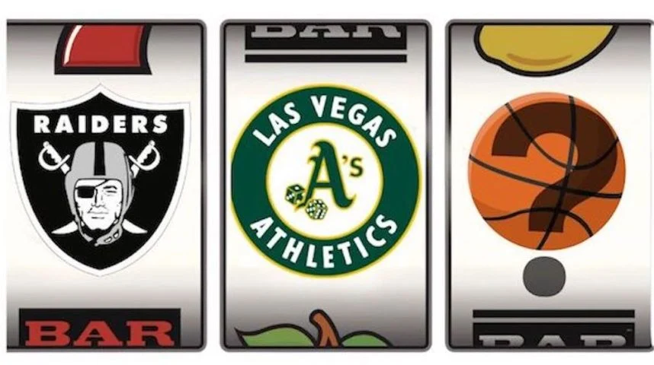

**Final Project: NBA Expansion Team in Las Vegas**

Julie Athanasiadis, Jaelyn Eisenhart, Grace French

MSDS 457 - Sports Management Analytics

**Introduction**

It’s no secret that Las Vegas is a heavily considered market for an NBA expansion team. A Washington Post article details LeBron James’ desire to own a team in this entertainment and gambling destination. After playing a preseason game at T-Mobile Arena, James acknowledged the wonderful fan support in the city, and he has the billion-dollar net worth to bring a new NBA team to life (Golliver, 2022). As members of the analytics department for the NBA expansion team in Las Vegas, the Vegas Vipers, we wanted to address the city’s sports market. Las Vegas has had an increasing presence in the sports industry as it is home to NFL, NHL, and WNBA teams. By sharing the state-of-the-art T-Mobile Arena with the Vegas Golden Knights, the Vipers would immediately have a home and excited fan base. Per the Sports Media Watch that ranked the top 115 U.S.- based “Big Four” professional sports teams and 80 “Power” conference college programs based on Nielsen TV market sizes, Las Vegas fell 40th (“Major Pro Sports…”, 2018). This number is solely determined by the number of homes in the city, and it does not take into consideration that Las Vegas is an entertainment destination. The Vegas Vipers will be able to attract tourists and build a fanbase with existing and new residents moving to the growing city.

This report analyzes two components that are crucial for the Vipers’ success: revenue generation and roster acquisition. These revenue generating components we analyzed include sponsorships, customer relationship management (CRM), and ticketing and attendance. The roster component includes player acquisition, salary, and team and player performance. Each factor has a significant impact on NBA teams’ valuations. Sponsorships are a growing industry in the NBA and team sponsorship revenue has reached $1.5 billion during the 2023-24 season (Badenhausen, 2024). A team needs to prioritize CRM strategies to positively interact with their fans and ensure they continue to buy tickets and attend games. Since this is an expansion team, player acquisition is necessary. It will help us determine the roster to estimate expected costs for player salaries and estimate future team performance. Understanding each of these key elements will help the Vegas Vipers reach their goals on and off the court.

**Literary Review**

The study detailed on Statatholon examines the Four Factors of Basketball success, originally proposed by Dean Oliver, which aims to predict game outcomes by focusing on key performance metrics. These factors include Effective Field Goal Percentage (eFG%), Turnover Rate (TOV%), Offensive Rebound Rate (ORB%), and Free Throw Rate (FTr) (Oliver, 2004). The study utilizes more recent data from 2012-2017 NBA seasons, analyzing the performance of all 30 teams. Two models were employed: one using Oliver’s original weightings (40% eFG%, 25% TOV%, 20% ORB%, 15% FTr) and another using adjusted weighting derived from regression analysis. The goal was to predict team win records and validate the significance of each factor. The regression analysis confirmed the importance of the Four Factors but suggested adjustments in their weighting to better reflect modern basketball dynamics. The adjusted model showed eFG% and TOV% had a greater influence, while ORB% and FTr were less impactful.   
 The adjusted model achieved a high accuracy level explaining 94% of win variations with a standard error of 3.2 wins (Statathlon, n.d.). The study emphasizes the enduring relevance of the Four Factors in analyzing team performance and predicting success. However, it also acknowledges the need for periodic recalibration of these metrics to maintain their predictive power, reflecting changes in game strategies and player roles over time. The Four Factors provide a robust framework for basketball analytics, offering valuable insights into team performance. Despite the original weightings requiring adjustments, the principles remain highly effective for predicting outcomes and guiding coaching strategies.   
 Another study by Dr. Jirda Poropudas also examined Dean Oliver’s Four Factors. This study aimed to refine the relationship between these Four Factors and team efficiency ratings using contemporary NBA data from 1996-1997 to 2022-2023 seasons. Utilizing updated NBA data calibrated the estimation formulas for the number of possessions, a critical element for calculating team efficiency ratings. The research incorporates play-by-play data to ensure accuracy, addressing changes in the game such as the increased emphasis on three-point shooting variations in free throw occurrences. The analysis details the multiplicative nature of the dependence between the Four Factors and team efficiency ratings, employing sensitivity analysis to determine the relative importance of each factor. eFG% remains the most significant factor influencing team efficiency, followed by TOV%, ORB%, and FTr. The research further demonstrates that while the exact values of rebounds and turnovers cannot be directly converted into points, the Four Factors collectively serve as robust predictors of team performance. Various mathematical models were employed to describe the multiplicative relationships between the factors and efficiency ratings, providing a nuanced understanding of how these metrics interact to influence overall performance. The offensive and defensive Four Factors, combined with the four shooting percentages encompasses “all of the information needed to assess the overall quality of a basketball team.” (Porpudas & Halme, 2023).   
 Medium article, “The NBA and Cable TV: A Relationship in Peril” by Eugene was helpful in understanding the NBA’s revenue and how it compares to other leagues. From 2022 estimates, the NBA falls second amongst the NFL, MLB, NHL, and MLS at $10.6 billion in annual revenue behind the NFL at $18.6 billion. From Forbes’ data for the 2022-23 NBA season, the league generates 50.47% of their revenue from media, 16.53% from general seating, 12.10% from premium seating, 11.81% from other revenue streams, and 9.10% from arena sponsorship and advertising. The other streams include concessions, merchandise, league licensing, parking, and non-NBA event revenue. Eugene describes the NBA Viewership Timeline over the past 30 years and how viewership is dwindling despite the changing landscape of sports viewership and increasing media rights deals.  
 Another Medium article, “Is This The Peak for Sports Team Valuations?” by Eugene, details multiple NBA ownership changes toward the end of 2022 and 2023 and media deals that are expected to triple its revenue (Eugene). The author presents data that shows average NBA franchise valuations since the 2000’s. The 9-year $24 billion deal in 2014 with ESPN and Turner Sports “exploded the league’s annual media rights revenue from about $966 million to $2.6 billion” (Eugene). Franchise valuations have also continued to increase with teams being valued at $3 billion or more as of 2023. Eugene assesses the nature of the market that supports these high valuations by analyzing the NBA’s youthful fan base, global interest of the league, and the finite number of teams. The author believes some challenge areas include future media rights deals and upstart competition abroad.   
 C. Keith Harrison and Scott Buksteins’ *Sports Business Analytics: Using Data to Increase Revenue and Improve Operational Efficiency* has a chapter titled “Communicating the Value of Sports Sponsorship.” The authors describe how most sports organizations use “recaps” to communicate the value of sponsorships to corporate partners, but they have a history of incorporating limited quantitative data. Through inherent, relative, and comparable analysis of sponsorship inventory, organizations can demonstrate the value they generate to sponsors. Additionally, “Assessing Returns from New Sport Marketing Opportunities: The Case of NBA Jersey Sponsorships,” Jonathon A. Jensen, Brian R. Walip, and Adrien Bouchet conducted a study quantifying the returns that marketers receive from investing in an NBA jersey sponsorship. The methodology identified the expected return of the stock around the event based on the stock’s normal relationship with their market returns. The authors determined that sponsors investing in these sponsorships achieved a positive abnormal return on their investment, given the novelty of the sponsorship opportunity and the possibilities of modern world brand integration.  
 Lastly, navigating and understanding NBA teams’ financials and player contracts is a hard task, and there are times when you need a glossary of terms. For example, a team can reach four types of salary ceilings – cap, luxury cap, first apron, and second apron. Restrictions and tax sanctions are implements to keep NBA teams within an appropriate amount; however, every team went over the cap in the 2023-2024 season. Additionally, there is a clear correlation between spending and winning, with twelve of the top fifteen spending teams making playoffs in 2023-2024. Team valuations are increasing, as so are player contracts, making managing salaries difficult for teams to balance. For example, supermax deals are designed to help retain loyal top talent by allowing teams to re-sign a player who has played at least 7 years with that team, for a maximum of five years for an amount up to 35% of the salary cap subject to an 8% annual increase. (Sportac) There are certain conditions that need to be met for a player to qualify, such as making all NBA-team or becoming MVP. Jaylen Brown just signed a supermax deal worth $286,230,000 over 5 years, and Luka Doncic is poised to be the first player to reach $70/million a year when his opportunity for a supermax contract comes in the 2025 offseason. (*Luka Doncic 2025*, 2024) Forecasting salaries are also challenging due to the different types of player contracts, market forces, player health, aging factors, and player marketability. There are multiple approaches to projecting and predicting salaries. With their paper, “Classification of NBA Salaries through Player Statistics,” the Berkeley Sports Analytics Group used K-means classification methods to predict free agency salaries with performance metrics. Some researchers used machine learning and regression models to predict NBA salaries. (Wu et al.) One author found that Random Forest and Gradient Boosting techniques performed better than Support Vector Machine (SVM), Elastic Net, Adaboost, Light Gradient Boosting Machine (LGBM) when predicting free agents’ salaries and discovered that the leading factors where minutes played, points, previous season salary, and advances player statistics. (Pastorello, 2023) For the purpose of our research, we evaluated all players from the previous five seasons and not just free agents. Hoping that this will improve our model’s performance in a short time of preparation.

**Revenue Component**

**Sponsorship**

***Methods***

We want to analyze what a potential front of jersey sponsorship could look like for the Vegas Vipers. For context, NBA front of jersey sponsorships became effective in 2017, and the industry has exploded since. We utilized data from “Assessing Returns from New Sport Marketing Opportunities: The Case of NBA Jersey Sponsorships” by Jonathon A. Jensen, Brian R. Walip, and Adrien Bouchet to aid our analysis. NBA sponsorship revenues have grown about 40% from the 2014-15 season at $739 million to the 2018-19 season at $1.21 billion (Jensen et. al, 2023). The authors conducted their analysis on 20 out of 44 sponsorships at the end of the 2021 calendar year, excluding private companies without stock prices and companies not traded on a US stock exchange. The study determined that in the context of naming rights sponsorships, a facility sharing the same metropolitan area as the sponsor led to greater returns. Additionally, high tech firms have earned greater returns across naming rights and title sponsorships as it signals the health of emerging firms to investors. Figure 1 shows two pie charts based on the companies described in the mentioned study. 61% of NBA front of jersey sponsors were tech based, and 55% had regional proximity to the team they sponsored.

**Figure 1***NBA Jersey Sponsors*

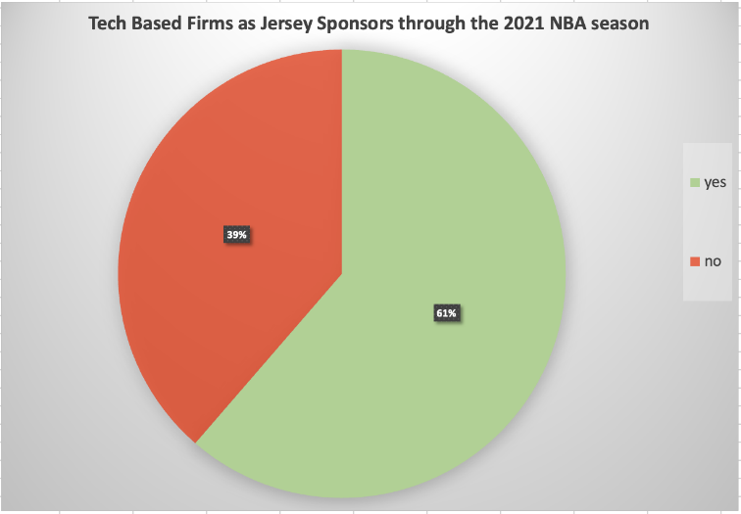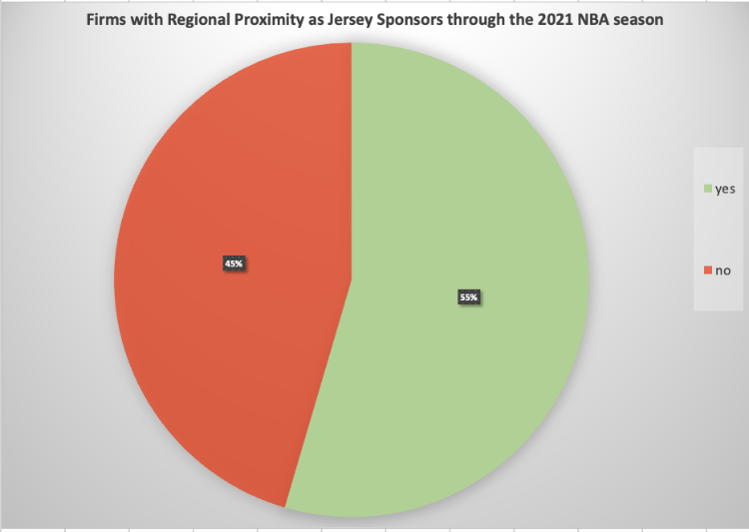

Based on this information, Table 1 highlights our priority list for potential front of jersey sponsors including five companies that are tech based and have headquarters in Las Vegas.

**Table 1***Jersey Sponsor Priority List*

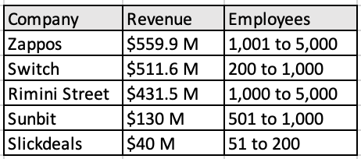

Additionally, we wanted to determine how much value the front of jersey sponsorship could generate for potential companies sponsoring the Vegas Vipers. In C. Keith Harrison and Scott Buksteins’ chapter titled, “Communicating the Value of Sports Sponsorship,” the most common measure of jersey sponsorship is the number of fans that attend a game. Broadcast viewable signage is also important in the calculation. An inherent valuation gives teams the ability to determine quality and quantity of impressions. We don’t have readily accessible access to that data, so we focused on the other two valuations Harrison and Buckstein mention: comparable and relative. Through a comparable valuation, we need to look at other organizations’ price points for front of jersey sponsorships. Our last sponsorship-related analysis will look at a relative valuation, examining the most common ratio in sports sponsorships and advertising, cost per thousand impressions (CPM).

***Results***

For the comparable analysis, sports organizations typically value their partnerships by pricing their inventory similar to other teams in the league or geographic location (Harrison and Bukstein, 2017). It keeps the industry competitive, and the numbers reflect different market sizes although it isn’t always clear what the assets should be priced. Smaller market teams were able to receive $9 million on average for each jersey sponsorship in 2017, but brands like Rakuten with the Golden State Warriors and Bibigo with the Los Angeles Lakers topped out at $20 million (Jensen et. al, 2023). The Vegas Vipers are a mid-market team and based on those numbers, they could be expected to have a front of jersey sponsor for around $9 million for the first year. Because those valuations occurred seven years ago, we would be looking at a current valuation upward of $11 million taking inflation and the developing economy into account.

Now using a relative valuation by looking at the CPM, the formula below analyzes the most common metric used in other advertising or marketing channels:

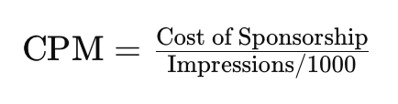

If we predict the front of jersey sponsorship to be priced at $11,000,000, we can use that as the cost of sponsorship in the equation. Next, we need to determine the number of impressions the asset would receive. We can look at impressions through in-person attendance, broadcast viewership, and social media value. The Vipers would play 41 games at home and 41 games away, without including the playoffs. T-Mobile Arena has a capacity of 18,000 per game, and the NBA generates an average of 1.62 million viewers per game (Karp, 2024). According to MVP index, the Milwaukee Bucks generated 256,957,844 social media impressions from Motorola, their front of jersey sponsor (“Analyzing the NBA’s…, 2022). Sports Media Watch deemed Milwaukee, home to the Bucks, to be the city with the closest market size to Las Vegas, so this was a relevant comparison. Summing these numbers for the entire regular season generated over 390,000,000 impressions. Therefore, the cost per thousand impressions totals $28.17. This ratio allows potential partners to determine if this asset fits in their budget and provides the necessary value relative to their other sponsorships. One thing to note is that the CPM calculated didn’t account for playoff games. If it did, it would decrease the ratio for each added game played away and at home.

**Customer Relationship Management (CRM)**

***Methods***  
 Our methodology approach for this section is to develop a five-year CRM plan consisting of various analytical tools and applications that deepens our understanding and connections with customers, expands our customer base and brand, and maximizes our profits from our customers and brand equity. Our strategy is carried out in three phases that will address our short-, intermediate-, and long-term goals.   
 **Phase One – Year One.** In phase one, which will be the first year, we will build our fanbase from the ground up and maintain the CRM software we have chosen. Growing the CRM for an expansion team is crucial to the team’s success and one of the biggest initial hurdles we will face. Team website traffic, email surveys, community events, enter-to-win contests, referrals, social media engagement, and partnerships with other teams are methods to increase your fan base. Since Vegas is our home city, other teams to connect with and cross-promote would be the WNBA team Aces, NHL team Golden Knights, and the new resident NFL team Raiders. In addition, the NBA has already test-run fan interest by hosting the first annual In-Season tournament at the T-Mobile Arena during the 2023-2024 season in December. The event saw a total of 53, 875 fans throughout the three-game series and had 19,021 fans for the final. To establish a great starting point for our CRM, we would reach out to the NBA for transactional and attendance data from this event. Most teams use Microsoft Dynamics CRM and Salesforce for their CRM software. Key features of CRM software include data importing, analytics, email integrations, mobile accessibility, email marketing, multichannel support, and SaaS integration. Successful teams use their CRM system not just as a static database, but also to proactively interact with and to search for ways to engage and increase revenue with their current customers and track methods in obtaining new customers.  
 **Phase Two – Years Two to Five.** Once we have an established CRM system and have a season or two under our belt, we will start incorporating analytics that capture and evaluate customer value, brand equity, and fan engagement. These will measure components such as projected revenue generated by fans over time, fans' willingness to buy their brand or attend games, and willingness to follow and interact with their social media pages. At this stage, additional software tools will be needed to conduct statistical modeling, such as python or R. In addition, we should have a robust data team with statisticians and analytical professionals, working alongside business professionals across all departments, not limited to customer relations and marketing. One of the most common customer analytical models in this stage is the customer lifetime value, or CLV. This measures the profitability of customers over a long period of time, which helps forecast future earnings and also serves as a marketing tool. One of the most explicit uses of CLV is with season ticket holders and with transactions traced in CRM software, we can also use their purchase history. For example, if a fan had purchased two season tickets for all forty-one home games totaling $8,200 averages $50 in food each night, and they are projected to be retained for next 10 years, their CLV would be $102,500. CLV can be expressed in the following equation. However, it is important to note that with athletic franchises, looking at CLV as a function of marketing decisions is required, as “investments into team quality are clearly 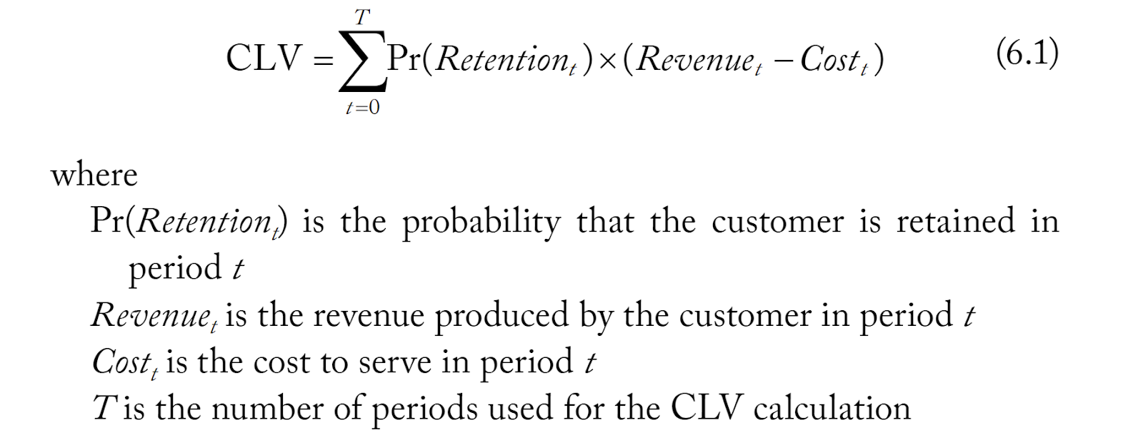linked to season ticket holder retention and willingness to pay.” (Harrison and Bukstein).

**Phase Three – Five Years and Beyond.** Phase three consists of long-term projects, advanced research, automation, and continuing analytical growth. Tasks in the first and second phase will continue as needed; however, this phase is for teams with more stability and resources to further advance their analytical edge, and also improve the team’s bottom line by increasing revenue and becoming more efficient. Further, technology and trends are constantly changing and teams that are better equipped to address these will fare better in the long run. Creativity in appealing to the younger generation and increasing our entertainment factor will drive a portion of this phase as well. For example, the Orlando Magic have led the way with developing the ultimate fan experience through their Magic Money program and app. Fans earn Magic Money that they can exchange for discounts on food and drink, seat upgrades, and creative fan experiences like taking a tour or attending meet and greets (Harrison and Bukstein 2017). We will aim to implement something similar as we are within the walls of Vegas, a major tourist destination and entertainment hub, and will need to compete for interest.

***Results***  
 Our results will be dependent on us carrying out our plan successfully. The three-phase CRM approach is realistic yet encouraging. We understand as an expansion team, our short-term goal is the most important, which is to gain a fan base and continue to advertise and push our product to the region. In a market with many competitors, we will rely on our analytical competitiveness to gain an edge, and with an active, not static, approach to our CRM, we can capitalize on our customers, brand, and fan engagement. A summary table of the three phases is seen in the table below:

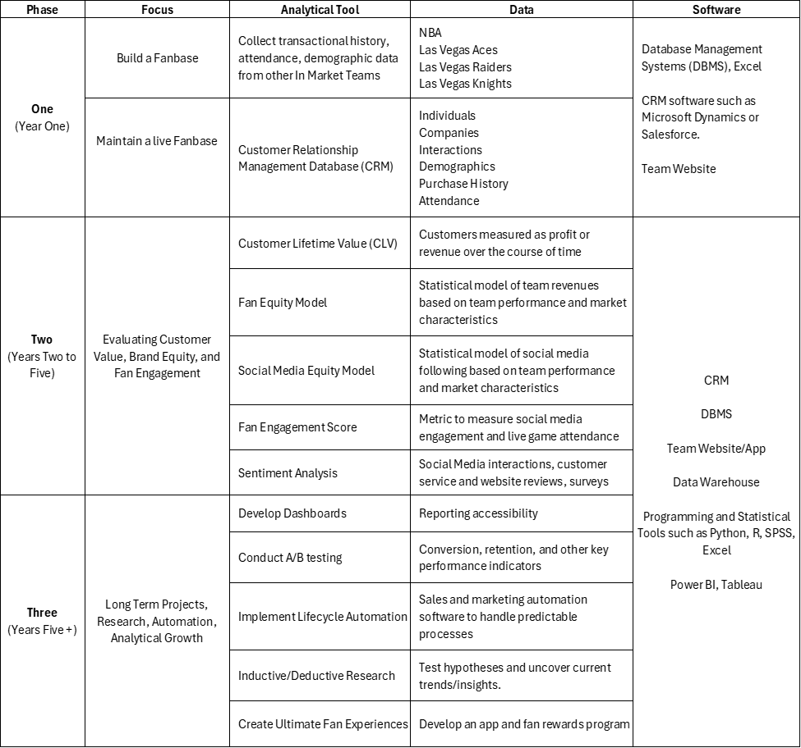**Table 2***CRM Strategy with Three Phases*

**Ticketing and Attendance**

***Methods***

Our methodology and process for estimating ticketing and attendance was from a consultative perspective. We used data acquired from ESPN to analyze the 30 NBA teams and Hockey-Reference to gain information about the Vegas Golden Knights. The Golden Knights were included in this analysis because they share the same market as the Vegas Vipers, have the same capacity (share the same venue), and have the same amount of home games. The 2022-2023 season data was used for the NBA teams, given that every team played the exact same number of home games (41) throughout the season. The current season was not used due to a variation in the number of home games per team. The most recent 2023 NHL season data was used for the Vegas Golden Knights data. A combination of historical and comparative analyses was used to determine the best ticketing strategies.

***Results***

Using a comparative analysis, seen in Table 3, the relationship between average ticket prices and average attendance is inconsistent. In some cases, high ticket prices are associated with higher attendance, while other times high ticket prices are associated with lower attendance. For example, the Los Angeles Clippers have the third highest average ticket price of $267 and have an average attendance of 17,574 (capacity 18,000), while the Memphis Grizzlies have an average ticket price of $73, with an average attendance of 17,264 (18,119 capacity). These results are inconclusive regarding the best methods for ticket pricing. However, when using historical analyses, we understand that ticket price is significant in determining attendance of an NBA game. The higher the prices are statistically related to lower attendance (Coates, Dennis & Humphreys, 2007). As a result, research suggests the use of both variable and dynamic pricing. This flexible pricing model allows sports organizations to adjust prices based on various factors to maximize revenue.

**Table 3**  
*Comparative Analysis of NBA and Vegas Knights Ticket Price and Attendance (2023)*

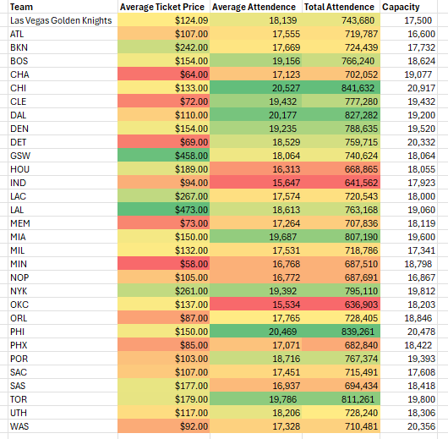

**Roster Component**

**Player Acquisition**

***Methods***

Before we conducted our player acquisition analysis, we gathered data from Basketball-Reference and Spotrac. We looked at NBA players’ player efficiency rating (PER) and their relative salary for the 2023/24 season. Developed by ESPN.com columnist John Hollinger, he described PER as the sum of all player’s positive accomplishments, subtracts negative accomplishments, and returns a per-minute rating of a player’s performance (“Calculating PER”). A variety of knapsack problems with different constraints made our acquisition strategy possible. Our player production data had multiple rows of data for the same player if they were on more than one team during the 2023/24 season. We cleaned the data by looking at player data specifically for their current team. Additionally, we wanted to make sure that our final database only looked at players who were involved throughout the season, so we excluded players that played less than 20 NBA games. We created working data for the optimization problem that included the Player, Position, Age, and PER. The objective was to maximize player efficiency rating based on position. Setting up 5 individual knapsack problems, we found the top 10 players for each position (centers, point guards, shooting guards, power forwards, and small forwards) based on PER. Through linear and integer programming, the best players in the league categorized by position were outputted.   
 After creating a data frame of the 50 players and their respective positions, PER, and salary, we determined what roster would be the most realistic based on an expansion team’s salary. According to Spotrac, a first-year team utilizes 66.6% of the NBA’s salary cap (Smith, 2023). As next year’s projected salary cap is $141 million, the Vegas Vipers will have $93,906,000 available. The constraints for this knapsack problem included maximizing PER, 3 players per position, 15 players in total, and under $93,906,000. Based on our analysis, our roster is displayed in Table 4:

**Table 4**  
*Initial Roster*

***Results***

According to the rating PER system, the average NBA player is a 15, a great player is in mid to high 20’s, and a poor player is below 10 (Sicko, 2024). From Table 4, we can see all of our players have relatively high PER and will positively contribute to our roster. Daniel Gafford, Tyrese Haliburton, and Andre Drummond have a rating of 23 and above. Franz Wagner and Amen Thompson have the lowest PER which is still above average. Our acquisition was not traditional and led to all of our players having an average to high rating. Additionally, Haliburton and McConnell both play on the Indiana Pacers as point guards, so it would be extremely hard for the Pacers to ever let both of them go in the real world. Barnes and Markkanen are All-Stars, and there is a lot of young talent on the team through Segun, Ball, Thompson, and Wagner. Our model was based on a hypothetical approach, but if we could obtain as many of these players as possible, the Vipers would be in a good position.

**Salary**

***Methods***

Projecting salaries is a complex undertaking. To approach this, we used a mixed-methods approach, by incorporating both statistical modeling based on performance, date, age, and salary, and qualitative factors that comprise personalities, such as teamwork, effort, leadership, and likeness. Lastly, market trends are also analyzed for long-term salary projections.   
 For the analytical model, we used Google Colab and developed an RNN deep learning model with performance indicators, age, and date to predict salary classification. This was a multiple step process that included: 1. Collected and cleaned NBA box score data from games in the 2019-2020 season through the 2022-2023 season. Our data was retrieved from Kaggle and Sportrac, and Basketball-Reference websites, and consisted of 85,129 rows. 2. Conducted an Explorative Data Analysis (EDA) to examine the data before we run the model. Figures 2 and 3 show the salary distribution, and feature importance of salary, respectively. The salary distribution is rightly skewed, with 75% of the salaries below $12,420,000. The highest salary from this dataset is $48,070,014. Unsurprisingly, all performance indicators have a positive relationship with Salary. Age, points scored, assists, minutes played, plus minus are the most prominent features. Correlations between all features are highlighted in a matrix in Appendix A.

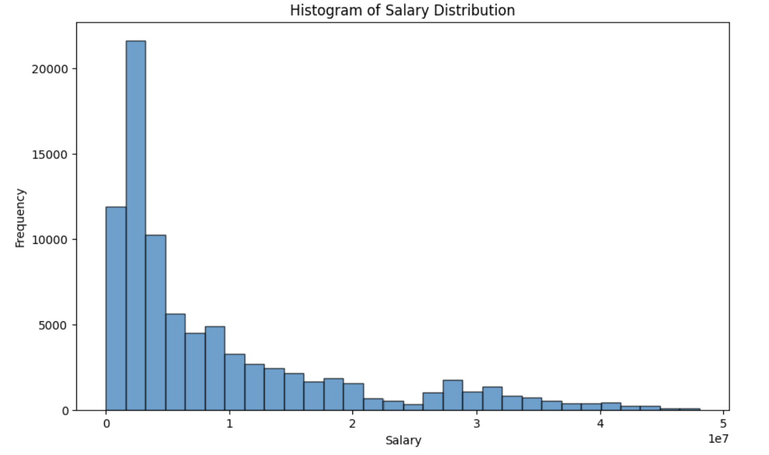**Figure 2***Salary Distribution from 2019-2023 Seasons*

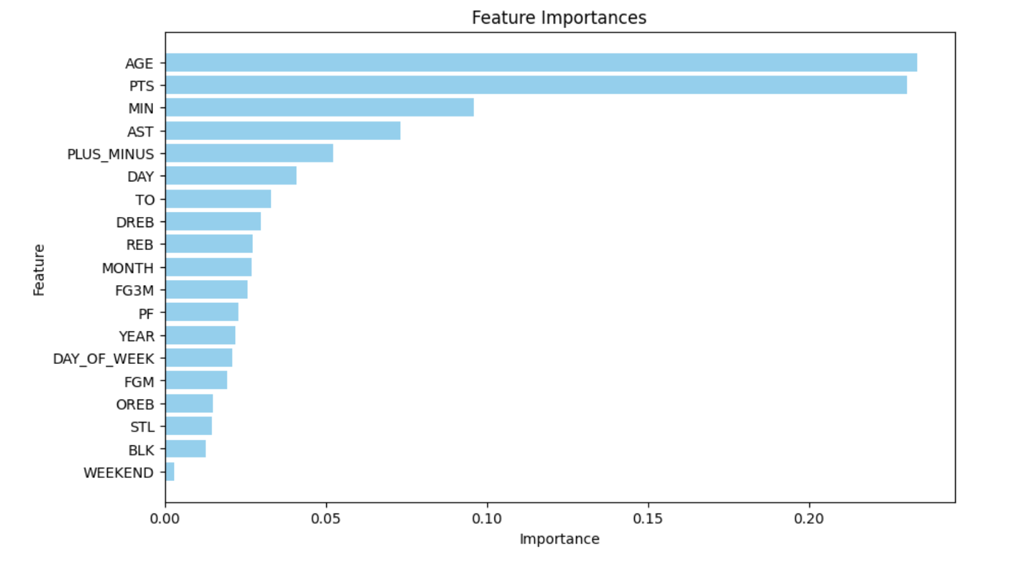**Figure 3***Relative Feature Importance in Regard to Salary*

3. We ran a random forest model and k means to determine the natural clusters from the data. We used these to set our bin boundaries based on salaries. Figure 4 shows the distribution of data within the new salary bins. 4. Then we split the data into testing and training sets. We applied the model with GRU layers and trained the model on the training set. One portion of the training set is split even further, into the validation set. This is a way to evaluate the model on new data, before it goes to testing data. 5. Then we evaluate the model and get performance metrics, such as accuracy on all three data sets - training, validation, and testing.

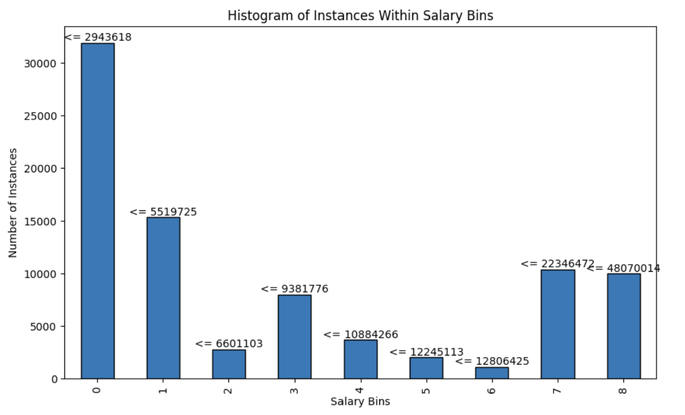**Figure 4***Salary Bins Distribution created from Natural Cluster in Data*

***Results***

Our model performed at its best with 68% training data accuracy and 54% testing data accuracy. This indicates that our model is performing better during training and is not generalizing as well to other datasets. This is considered overfitting, which means that the model is picking up too many precise patterns in the dataset, and we need to tweak our model by adjusting parameters or adding more regularization to help offset it. When we plug our current roster’s 2023/2024 performance averages into the model to predict salary for 2024/2025, the model correctly places 8 out of the 15 salaries. It under values five of the players, predicting that they make less than they do, and over values two, predicting that they make more than what they will in 2024/2025. Table 5 shows the model projections per player. More experimenting will help configure a model that is more accurate.

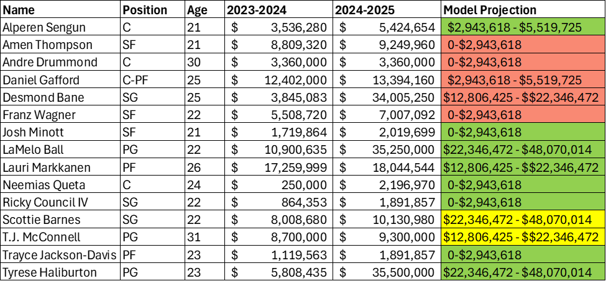**Table 5***Salary Projection on Current Roster with GRU Model*

To forecast salaries over the course of five years, our composite analysis will be used in conjunction with market trends, historical salary data, position needs, and unmeasurable constructs such as personality, willingness to work as a team, effort, leadership skills, coachability, and charisma. Taking these into consideration, we project our current team’s salary through the 2028-2029 season, and this is shown in table 6.   
 The average increase in salary per year for those not with a mega deal is %1.31 percent and those with a new deal is 6.7%. The average increase per year within a mega deal is %1.068966. Bolded numbers are contracts that are already set. Bane, Ball, and Haliburton have mega deals set in place for 2024-2025, and Markkanen, Gafford, Sengun, and Barnes are due for a significant deal in the 2025-2026 seasons. We projected Sengun to see a 6.7% increase due to age and performance, however, the other three we project a 3.0% initial increase, due to age, current salary, and market trends. Drummond is the only player without a significant deal. We project to have a %1.06 increase and not %1.31 due to age and performance. At 30, he is one of the oldest players, and his production is not as strong as the rest of the team.

**Table 6***Potential Salary Projections from 2023/2024 Season to 2028/2029 Season*

We have a very talented young team, but as they mature and progress in the league, they will price us out. Therefore, we need to strategically think about what influential pieces we would ideally like to build our team around. Since we are a new franchise, we will stick with one of our current stars and bring in a supporting cast. Using past salary adjustments, current performance, age, and market trends, Table 6 shows our projected salaries for our current roster over the next five seasons. With multiple rising stars, our total salary will quickly double that of the salary cap by 2025-2026. Even though most NBA teams operate over the salary cap, being a new franchise, we are looking to stabilize our salaries at a modest increasing amount and will need to make roster changes for the upcoming seasons. Below is one logical scenario we can explore. Key considerations:

1. Building a team around young stars in Haliburton, Markkanen, and Franz Wagner, veteran T.J McConnell, and developing players such as Neemias Queta. Ball is unfortunately injury prone and health risk became a factor. Haliburton showed leadership and marketability during the 2023 playoff run.
2. Per expansion draft rules, our second-year salary needs to stay at 80% and can go back to league normal in the third year. Even though all teams are over the cap, we chose to stay modest while trying to maintain competitiveness.
3. Focused on having a strong top 6-7 players, and supplemented the rest of roster with veterans, like Derrick Rose, and young incoming draft picks.
4. Maintained our average age was between 25.9 and 26.4. As we know age is a large contributing factor to salary, so focusing on harnessing young talent while relying on our initial roster’s experience to lead.
5. By keeping our total salary near the cap, as our original roster keeps aging, we will have room to keep them, such as utilizing the supermax deals. Or we can trade for other stars as we establish ourselves as a stable franchise.

Other strategies could include changing our key players to retain, trading for a bigger superstar after the first season, or even trying to draft Bronny James and receive him and Lebron in tangent to bring in fans immediately. Overall, salary projections will be supported by a combination of statistical models, forecasting analytics, market trends and forces, and unforeseen dynamic factors, such as injury, and personality characteristics, such as leadership, marketability, and effort. In addition, negotiations are a group effort with multiple stakeholders. However, analytical tools can serve a great purpose in helping create a baseline or reference point for discussions.

**Table 7***Potential Roster and Salary Projections from 2024/2025 Season to 2026/2027 Season*

**Performance**

In order to properly analyze our expansion team and their projected performance, we gathered data from Basketball-Reference. Many performance statistics for our roster were gathered including the Four Factors (eFG%, TOV%, ORB%, and FTr), all four shooting percentages (FG%, 3P, 2P%, and FT%), and win shares. Win shares is a player statistic that attempts to distribute the credit for team success to the individuals on a team. The win share system used follows the idea that a basketball team that wins 40 games should have about 40 win shares distributed amongst its players. Additionally, to accurately run comparative analyses and understand significant relationships between statistical values, similar data was acquired for all current NBA teams with the addition of collecting winning percentages.   
 Performance at both the team and individual player level was estimated. Multiple analyses were run to understand the LV Vipers estimated team performance. Moreover, we used player data from the past five seasons (2019-2020 season through 2023-2024 season) and their overall career values to get a better understanding of their individual player performance. To compare our team to other teams in the NBA, team data from the 2023-2024 season was used. All of the data for these evaluations was gathered from Basketball-Reference and input into datasets that were manually crafted by our team. The data was cleaned to account for missing values. Titles were also cleaned to ensure proper naming of each data point and necessary values were combined or averaged to use for later analysis.

***Team Performance***

***Methods - Win Shares and Winning Percentage***

Due to the unique nature of our player acquisition, we were able to create a very successful roster. Using the win share data, our team win shares and winning percentage were calculated. The resulting value was skewed very high due to player acquisition methods. Therefore, a historical performance adjustment percentage (HPA%) and cohesion adjustment percentage (CA%) were found. In order to calculate the HPA% the historical adjustment factor needed to be found. This value was discovered by evaluating the data of the most recent NBA expansion team data, the Charlotte Bobcats. The 2004-2005 team data was gathered to determine total wins (18) and winning percentage (0.220). The roster was then evaluated to determine the win shares each player contributed to their respective teams the season before. Once those values were found, the sum was calculated (12.7). This win share value was then subtracted from the actual wins of the expansion team. A difference of 5.3 was found. This difference was used to then find the historical performance adjustment percentage by dividing the difference by the total projected win shares and all multiplied by 100%. The resulting HPA% was 7.20%. The cohesion adjustment percentage of 20% was determined by previous studies that looked at the relationship between cohesion and performance of a sports team (Carron, Colman & Wheeler, 2002). Then these percentages were combined, resulting in an adjustment factor of 27.20%. This value was then contributed to our projected win shares (which we evaluated as win totals) and winning percentage.

***Results - Win Shares and Winning Percentage***

The regression analysis run to determine the relationship between winning percentage and win shares is shown in Figure 5. The analysis resulted in statistically significant results. The r-squared value was 0.9575, suggesting that this model accurately predicts the outcome of winning percentage 95.75% of the time. The Las Vegas Vipers’ winning percentage was estimated to be 0.908 with the lower confidence interval at 0.872 and the upper confidence interval at 0.943. This is where the adjustment factor of 27.20% was applied to the winning percentage, resulting in a 0.661 winning percentage for the Las Vegas Vipers inaugural season (lower interval 0.635 and upper interval 0.687).

**Figure 5**  
*Relationship Between Win Shares and Winning Percentage for the NBA (2023-2024)*

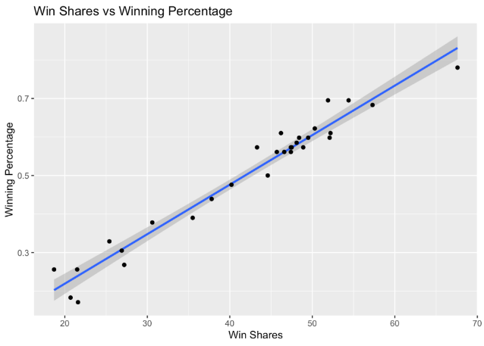

These results are vastly larger than data from other expansion teams including previous NBA expansion teams. As mentioned above, the data from our model is significantly higher than typical expansion teams due to our player acquisition model. Our acquisition model allowed us to select multiple players with high PER that contribute to greater success of our team. One piece of historical data that produces similar results to our findings is the winning percentage data from the NHL expansion team, the Las Vegas Golden Knights. In the Golden Knights inaugural season, they had a winning percentage of 0.622. Therefore, with the interpretation of the above results, it is logical to conclude that the Las Vegas Vipers would have a successful first season.

***Methods - ORTG Analysis***

To further analyze our performance as a whole team, a comparative analysis was conducted to evaluate team performance. The offensive rating (ORTG) was calculated and compared to the other 32 teams in the league. The equation for calculating ORTG includes the use of the Four Factors as well as a Mu value estimated to be 𝛍 = 0.42 according to previous analysis conducted using NBA data (Poropudas & Halme, 2023). The equation is as follows and the values for each team are seen in Figure 6:

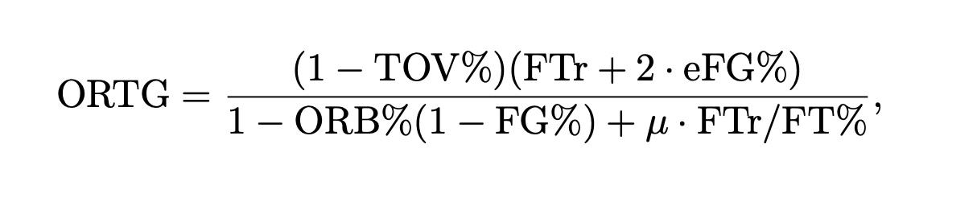

**Figure 6**  
*ORTG Ratings per Team*

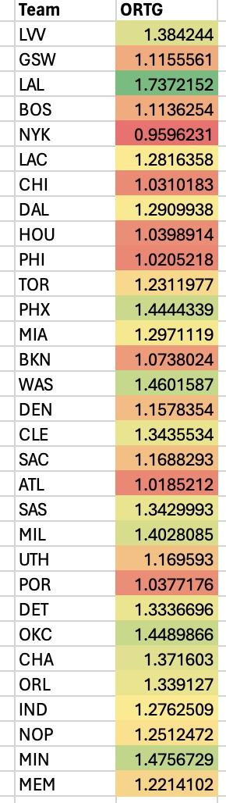

***Results - ORTG Analysis***

Using comparative analysis, we see that the Las Vegas Vipers ORTG (1.384244) falls slightly above the mean of the NBA (1.2946515).

**Figure 7**   
*ORTG per Team (including LV Vipers)*

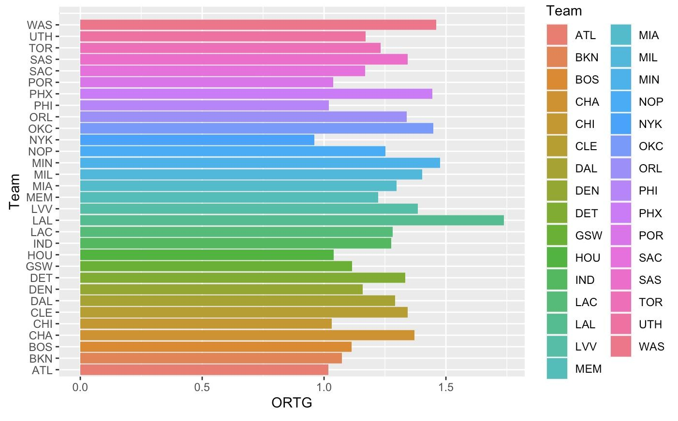

When trying to interpret our team performance as a whole, ORTG is an effective gauge to determine where our team falls within the league. The findings of Dr. Poropudas and Halme, claims that the offensive and defensive Four Factors, combined with the four shooting percentages encompasses “all of the information needed to assess the overall quality of a basketball team.” (Porpudas & Halme, 2023). Therefore, we found it insightful and important to analyze the ORTG of our team and compare it to the league as a whole.

***Player Performance***

***Method - Win Share per Player***

Additionally, comparative analysis was run to evaluate our players’ individual performance. The latest 2024 data for the win share statistic was used to analyze their contribution to the team. In order to acquire this data, the win shares each of our players contributed to their previous team was considered. To reference the data set that includes the entire LV Vipers player data over the years, refer to Appendix B Win shares are one of the most useful tools to indicate a player’s overall importance in their team’s ability to win (South, 2024).

**Figure 8**  
*LV Vipers Individual Player Win Shares (2024)*

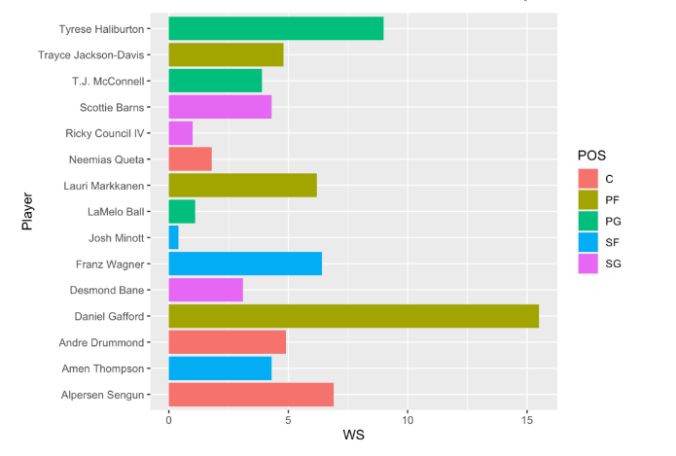

***Results - Win Share per Player***

Given the analysis above we see that Daniel Gafford contributed the most win shares (15.5) to our team by a large margin, while Josh Minott contributed the least (0.4). Additionally, the model provides differentiation through position to allow for further comparison. As previously mentioned, the relationship between win shares and team performance (winning percentage) is statistically significant and a good determinant in predicting the success of a team.

***Methods - Career eFG% per Player***

Finally, to further examine the impact each individual player on our roster would have, eFG% was analyzed throughout the past five years of each player's career. For individuals that have not been in the league that long, all of the data for their career was provided, and the data was cleaned for missing values. eFG% is arguably the most important stat of the Four Factors since throughout a game, the majority of the points are scored from the field. Therefore, this was determined to be an important statistic to analyze separately.

***Results - Career eFG% per Player***

The results allow us to analyze numerous pieces of information on each individual player. The results are seen in Figure 9. For example, the median eFG% for each player is represented by the central tendency line in each box. The interquartile range of the box plots shows the spread of the data for each individual over the past five seasons. This data is helpful in determining the performance of our players throughout their career.

**Figure 9**  
 eFG% of Las Vegas Vipers Players Over Their Career

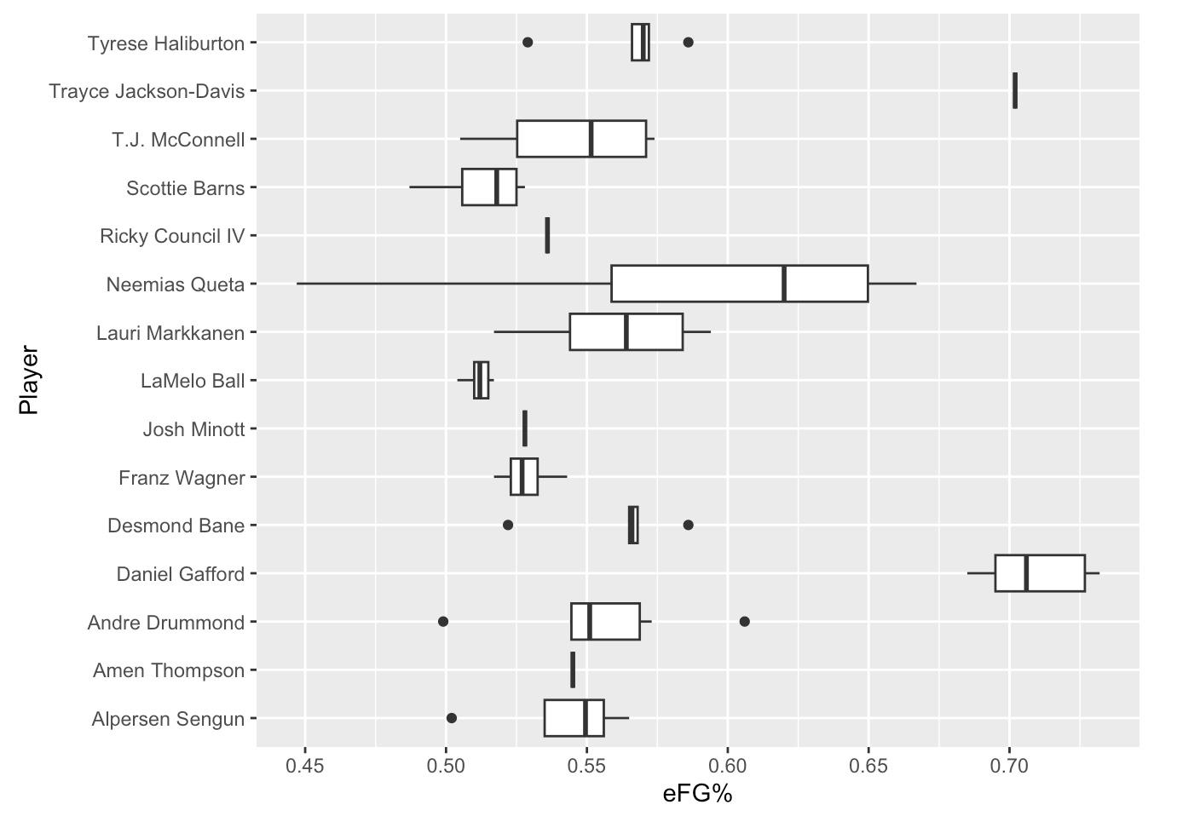

**Conclusions and Recommendations**

To conclude, we wanted to address any limitations and how that will guide our future analysis. First, our approach to the Vipers’ sponsorship only considered front of jersey sponsors. There are additional ways we can build our revenue through other available assets including social media campaigns, dashboards, and suites in the arena. Secondly, we had a lack of data as we conducted our CRM analysis. This would be the first year our team is active, and we need to build our fan base from the ground up. As we make our mark in the NBA, we will have more transactional data to utilize for our CRM model.

Similarly, this data void affects our analysis for ticket sales and attendance, and it would be advantageous for us to seek out other leagues’ data to gain a better understanding of how pricing impacts ticket sales. Another major limitation is that our findings were gathered through comparative and historical analyses that do not provide highly accurate results. More comprehensive analyses should be conducted in the future to gain a high-level understanding of the relationship that exists between ticket prices and attendance. Further, other factors such as day of week, opponent, star players, and team performance should be considered to determine if a relationship exists between these factors, ticket sales and attendance.   
 Regarding our roster, our approach didn’t follow the traditional NBA expansion draft rules, and our player acquisition model only focuses on player efficiency rating. While our method generated the best players in the league to be on our team, it wasn’t necessarily realistic. Additionally, our team and player performance indicators should be expanded on once the team actually plays together. The performance model can be enhanced by including more factors that could contribute to performance such as age, position, and other varying statistical data points. The next steps for this piece would be to analyze many varying factors and determine a significant relationship on winning, the Four Factors, and the varying shooting percentages. Lastly, our salary classification model is only 54% accurate. While this is more accurate than guessing, it needs improvement. Eventually, we want to create a regression model to predict actual salary. Other influential features would be measured such as a player's personality and marketability in addition to dynamic factors like aging, trades, injuries, and team chemistry. Constant evaluation and reassessment of the current team state is needed for short- and longer-term salary and roster planning.

Overall, by recognizing these limitations and addressing them in future analyses, we aim to refine our strategies and develop a more robust understanding of the factors influencing the Las Vegas Vipers’ performance and revenue generation, enhancing our decision-making processes and long-term success.

**References**

“Analyzing the NBA’s Regional Relevance on Broadcast and Social Media.” MVP Group, Inc, _______2022. *Www.mvpindex.com*, www.mvpindex.com/reporting/nba-recap.

Badenhausen, Kurt. “NBA Sponsorship Revenue Hits Record $1.5B, Fueled by Tech Brands.” _______*Sportico.com*, 21 May 2024, www.sportico.com/business/sponsorship/2024/nba-_______sponsorship-revenue-record-1-5b-fueled-by-tech-brands-1234779660/#.

“Calculating PER.” *Basketball-Reference.com*, www.basketball-_______reference.com/about/per.html#:~:text=In%20John.

Carron, A.V., Colman M. M., & Wheeler J. (2002). Cohesion and Performance in Sport: A Meta

Analysis. Journal of sport & exercise psychology, 24, 168-188.

Coates, Dennis & Humphreys, Brad. (2007). Ticket Prices, Concessions and Attendance at

Professional Sporting Events. International Journal of Sport Finance. 2. 161-170.

DeMeyer, Tess. “Charles Barkley Shares Concerns about TNT’s Future: “It Is Brutal.”” *The New York Times*, 15 May 2024, [www.nytimes.com/athletic/5495634/2024/05/15/charles-barkley-tnt-lose-inside-nba/#](http://www.nytimes.com/athletic/5495634/2024/05/15/charles-barkley-tnt-lose-inside-nba/).

ESPN Internet Ventures. (n.d.). ESPN. https://www.espn.com/nba/attendance/_/year/2023.  
  
Eugene. “Is This the Peak for Sports Team Valuations?” *Medium*, 23 Jan. 2024, ______medium.com/@eugene.okwach/is-this-the-peak-for-sports-team-valuations-_____dd2ce6c2dd38.

Eugene. “The NBA and Cable TV: A Relationship in Peril.” *Always Learning*, 6 Jan. 2024, eugeneo.substack.com/p/the-nba-and-cable-tv-a-relationship?utm_source=profile&utm_medium=reader2.

Friend, Tom. “Sources: NBCUniversal in Driver’s Seat with NBA Media Rights Negotiations, in Line for Third Package.” *Www.sportsbusinessjournal.com*, 9 May 2024, [www.sportsbusinessjournal.com/Articles/2024/05/09/nba-media-rights-negotiations-update#:~:text=Sources%20continue%20to%20insist%20Comcast](http://www.sportsbusinessjournal.com/Articles/2024/05/09/nba-media-rights-negotiations-update#:~:text=Sources%20continue%20to%20insist%20Comcast).

Golliver, B. (2022). Lakers’ LeBron James wants to own NBA expansion team in Las Vegas. *The Washington Post (Washington, D.C. 1974. Online)*.

Harrison, C. K., & Bukstein, S. (2017). Sports business analytics: Using data to increase revenue ______and improve operational efficiency. CRC Press, Taylor & Francis Group.

Jensen, J., Walkup, B., & Bouchet, A. (2023). Assessing Returns from New Sport Marketing Opportunities: The Case of NBA Jersey Sponsorships. *Sport Marketing Quarterly*, *32*(1), 47–61. <https://doi.org/10.32731/SMQ.321.032023.04>

Karp, Austin. “NBA National Viewership up Slightly Heading into Final Months.” ______*Www.sportsbusinessjournal.com*, 26 Feb. 2024, ______www.sportsbusinessjournal.com/Articles/2024/02/26/.

*Luka Doncic is poised for richest NBA contract ever in 2025*. (2024, April 1). BasketNews.com. ______Retrieved May 30, 2024, from https://basketnews.com/news-204096-luka-doncic-poised-______for-richest-nba-contract-ever-in-2025.html.

“Major pro Sports Teams Ranked by Market Size.” *Sports Media Watch*, 26 Oct. 2018, ______www.sportsmediawatch.com/nba-market-size-nfl-mlb-nhl-nielsen-ratings/.

Marcos, F. M., Miguel, P. A., Oliva, D. S., & Calvo, T. G. (2010). Interactive effects of team

cohesion on perceived efficacy in semi-professional sport. *Journal of sports science & medicine*, *9*(2), 320–325.

*NHL Attendance*. Hockey. (n.d.-b). https://www.hockey-reference.com/friv/attendance.cgi

Pastorello, G. (2023, August 24). *Predicting NBA Salaries with Machine Learning | Gabriel ______Pastorello*. Towards Data Science. Retrieved May 30, 2024, from ______https://towardsdatascience.com/predicting-nba-salaries-with-machine-learning-______ed68b6f75566

Poropudas, J., & Halme, T. (2023). *Dean Oliver’s four factors revisited*. ar5iv. ______https://ar5iv.labs.arxiv.org/html/2305.13032

Sicko, Don. “Player Efficiency Rating (PER): What Is per in Basketball?” *Hoop Coach*, 7 Apr. ______2024, [www.hoopcoach.org/player-efficiency-rating-per-simple-things-to-know/#](http://www.hoopcoach.org/player-efficiency-rating-per-simple-things-to-know/).

Slutsky, P. byScott. (2020, October 15). *How do superstar players affect NBA attendance?* The

Sports Business Analyst. https://sportsbusinessanalyst.com/2020/10/15/how-do-superstar-______players-affect-nba-attendance/

Smith, Keith. “NBA Expansion Series: Expansion Draft Rules | Spotrac News.” *Spotrac.com*, 6 ______Dec. 2023, [www.spotrac.com/news/_/id/2086/nba-expansion-series-expansion-draft-______rules](http://www.spotrac.com/news/_/id/2086/nba-expansion-series-expansion-draft-______rules).

South, M. (2024b). *Use NBA win share stats to win bet on the NBA*. Sports Betting Dime. ______https://www.sportsbettingdime.com/guides/how-to/nba-win-______shares/#:~:text=NBA%20win%20shares%20are%20most,players%20on%20less%20succ______essful%20teams.

Wu, William, et al. “Classification of NBA Salaries through Player Statistics.” *Sports Analytics Group at Berkeley*, chrome-extension://efaidnbmnnnibpcajpcglclefindmkaj/https://sportsanalytics.studentorg.berkeley.edu/projects/nba-salaries-stats.pdf.

**Appendix A**

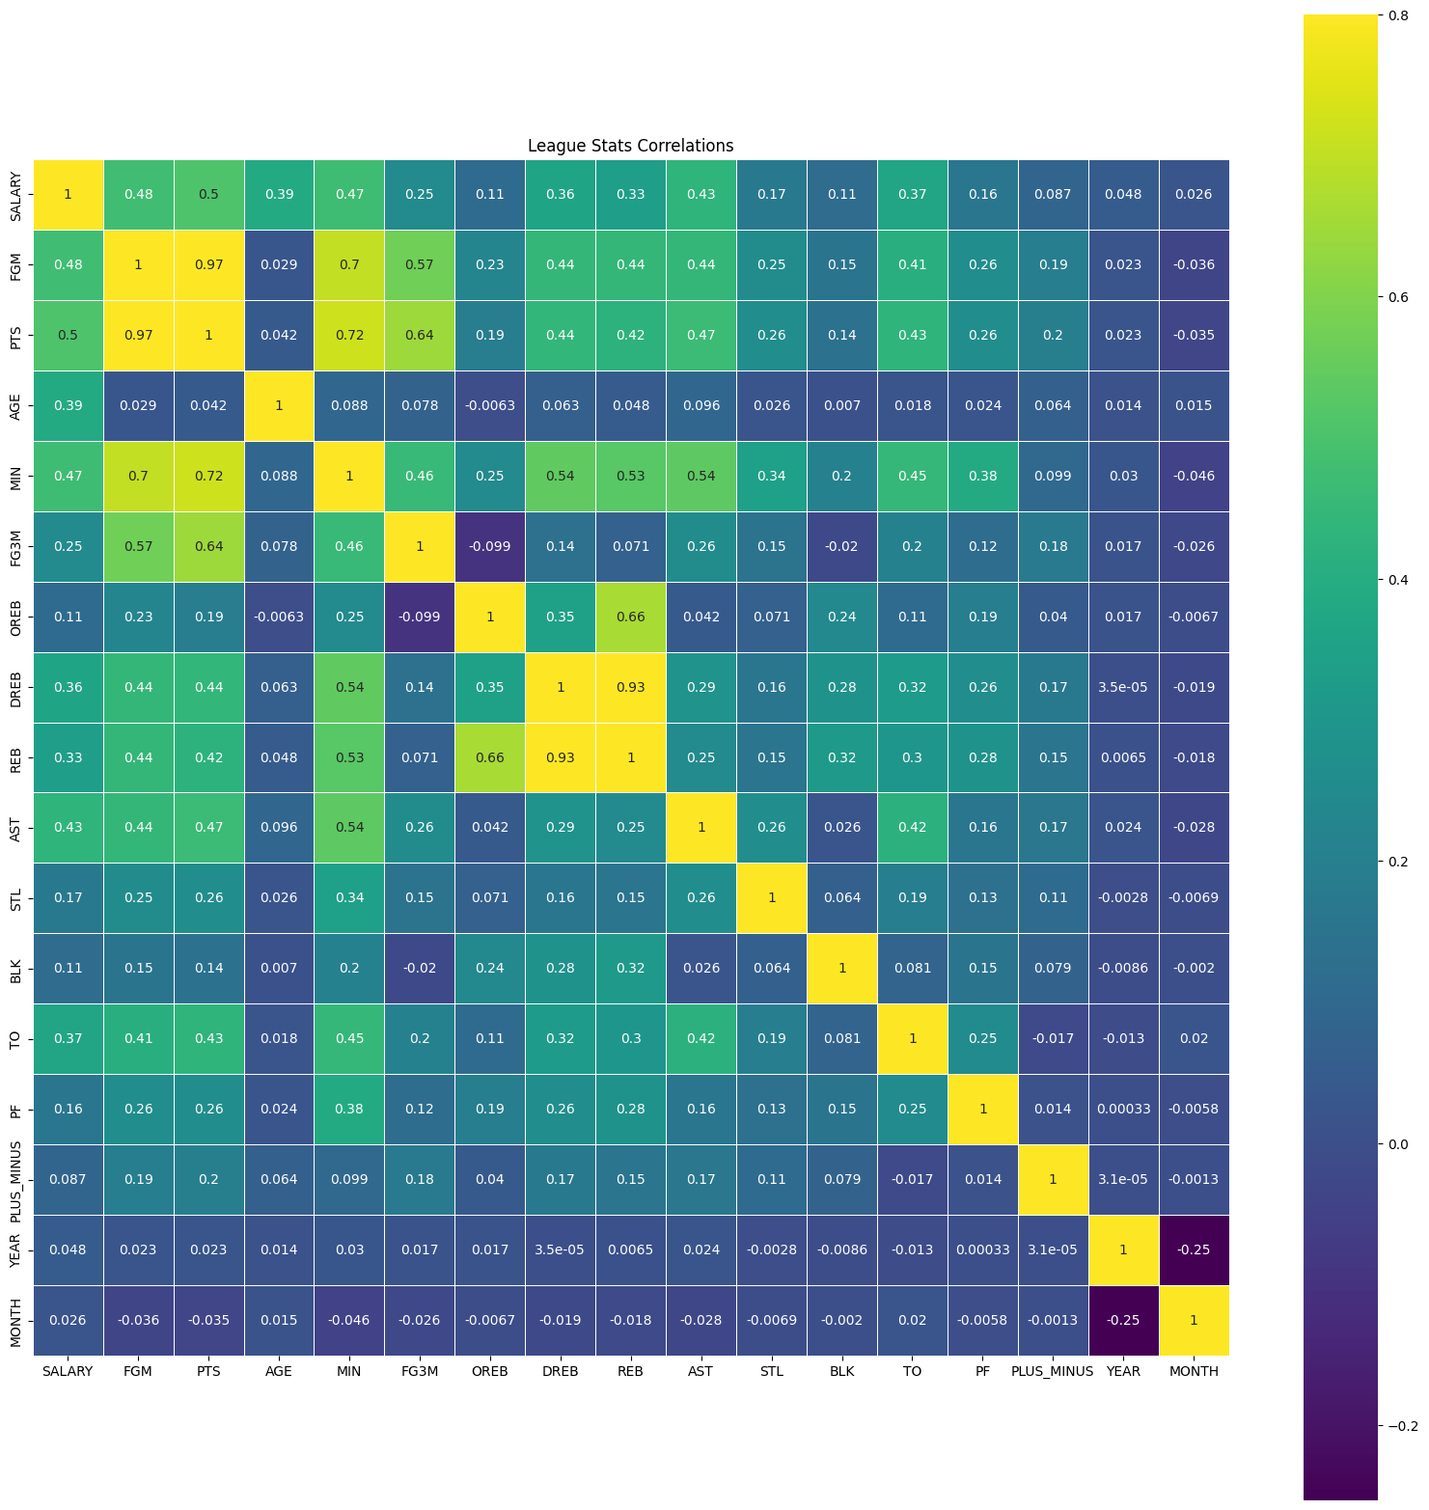Feature Correlations in Salary Classification Model

**Appendix B**

Las Vegas Vipers Player Data from Last Five Seasons (2019-2020 to 2023-2024)

